Kol Simcha Torah Gazette
For parshas vaeschanan 5786
Vol 10 Issue 41 (Whole #506) 11 Menacchem Av 5786/ July 25, 2026
Printed L’illuy nishmas Nechama bas R’ Noach, a”h
For a free subscription, please forward your request to keren18@juno.com
Past emails can be found on the website ShabbosStories.com under Brooklyn Torah Gazette
How Can Jews Properly Mourn the Loss of the
Beis Hamikdosh?
By Daniel Keren

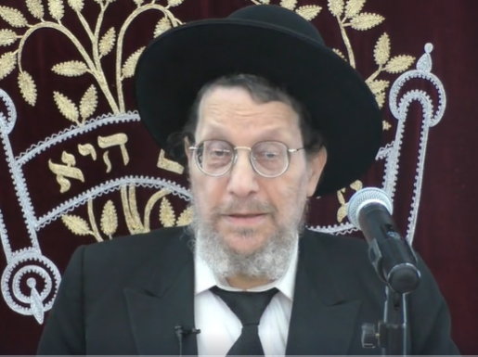
Rabbi Dovid Ribiat

One of the featured speakers at the recent Flatbush Independence Day Hakhel Yarchei Kallah Event was Rabbi Dovid Ribiat, author of Sifrei halachas, including the monumental multi-volume work – “The 39 Melachos”. The topic of his lecture was “The Halachos and Hashafos of the Three Weeks and the Nine Days: Doing What is Right!”
Noting that this legal holiday for Independence Day was “blessed” with a very uncomfortably hot temperature, Rabbi Ribiat recalled a teacher of his who had during the Second World War learned Torah in Shanghai, China. He remembered that the weather for many months of the year in Shanghai was oppressively hot. Many of the talmidim had taken off their jackets and and were still suffering from the oppressive heat. The Beth Aharon Synagogue in Shanghai where the Mirrer Yeshiva students studied 80 years ago, unlike today’s shuls and yeshivas, did not have the benefit of air conditioning.

The Dinim of the Three Weeks are Very Complex
Rabbi Ribiat emphasized that the dinim (laws) on these days applying to the Three Weeks [of Mourning] for the Churban Beis Hamikdosh (the Destruction of the Holy Temples in Yerushalayim) are indeed very complex and the reason for that is because a lot of these dinim are developments which originally developed at the time of the Churban but continued to expand over the centuries. And some of those additions are very confusing and difficult to understand.
Therefore, it takes effort. It takes an effort like those of you who came to hear this lecture on a very hot and uncomfortable day. It shows a demonstration of ahavas Hatorah.
Why is it so important to think about these dinim? And why did our Sages make so many halachos (laws) and minhagim (customs) that evolved over the centuries. A lot of which you can find towards the end of the third perek in the Gemara Bava Basra.
When the Second Bais Hamikdosh was destroyed, Rabbi Ribiat said it was very hard to grasp the immensity of that tragedy. But simple people, not just the gedolim, expressed their feelings that in their eyes the Churban was like the destruction not just of the Holy Temple, but that of their entire world.

The Destruction of both Bais
Hamikdoshes Was Not by Chance
The two Churbanos (the destruction of both Bais Hamikdoshes) was not by chance, even though it occurred at the same time of the Jewish calendar year. It was really connected as one tragedy. Even during the time of Bayis Sheni, there was never a complete restoration of the glory of the Jewish nation in the aftermath of the Churban of the First Beis Hamikdosh.
When Yehoshua (Joshua) sent over the two spies and they came to Yericho (Jericho), Rachav the innkeeper who hid them told them that for the past 40 years after Jews left Egypt the hearts of the inhabitants of Canaan had melted in fear based on genuine respect for the Children of Israel whom they feared were going to take over the Land of Canaan.
That kind of attitude of respect and fear by non-Jews was unfortunately not the same during the time of the Bayis Sheni (Second Temple). It was a slow painful process before the Bayis Sheni was built and it was not with the same grandeur of the original Bayis Rishon (built by Shlomo Hamelech) until later when Herod made the Second Holy Temple more splendid. And even then it had to be done with the consent of a foreign and occupying government. The Gemara describes how inferior the Bayis Sheni was compared to the Bayis Rishon. Many of the great miracles of the First Temple were simply not there.

What Was the Worst Tragedy
in the History of Our People?
We look at the Holocaust and we think to ourselves that this must have been the worst tragedy in the history of our people since the time of Avraham Avinu. But, Rabbi Ribiat declared that it is not true. If you look at what Chazal tell us about the Churban Bayis Sheni, many more millions were killed in that tragedy. And almost a century later there was a second terrible mass destruction of Jewish lives at Beitar which was connected to the Churban Bayis Sheni and more millions of our people were killed at that time too.
There were many perushim, Torah scholars who survived and they bitterly took on many chumros, stringencies, declaring that their lives could never be the same. They decided to no longer eat meat or drink wine, not even on Shabbos. One of the scholars at that time – the Tana Reb Yehoshua made it his business to involve himself in this new trend. He wanted to correct it. He questioned those perushim on this new chumra.
They responded to the Tana by asking how could they continue to eat meat and drink wine when they constantly reflected on how they could no longer bring offerings to the mizbeach, alter of the destroyed Bayis Sheni. Such offering included not only animal sacrifices but also wine libations poured over the altar.
So, the Tana Reb Yehoshua then challenged them by asking, why not extend your chumra to include lechem, bread since you can no longer bring menachos, meal offerings which is a type of lechem offering? They immediately agreed and said that we will just limit ourselves to peirus (fruits).
He responded perhaps you can’t do that because peirus were brought as bikurim (the first fruits) to the Beis Hamikdosh? They answered, OK, we won’t eat those type of fruits. The Tana then challenged them, how can you possibly drink mayim, water since that to was brought as libations on the mizbeach in the Temple? They were stumped and had no answer.
Rabbi Ribiat noted that the Tana Reb Yehoshua felt bad for them and said to them, My children, come here and let me explain something to you. I sympathize with you and also feel the same way about the korban (sacrifices). Of course we have to have some type of aveilus, mourning for the Churban Beis Hamikdosh. We have to remember it. But to take it to such extremes as you propose, is impossible because Chazal, our Sages never imposed a such a decree unless they thought the Jewish nation as a whole could abide by it.
There are no wiser people in all the world than the Torah scholars. And where did they get their knowledge from? From the study of the Torah, they understood human nature and they knew what type of decrees to impose. Such actions must be taken with the knowledge of not only how it will be accepted today but how it will be accepted going forward to the centuries ahead of us.

The World Cannot Endure Such Strict Restrictions
The Gemara concludes that the perushim were correct. But the world cannot endure such strict restrictions. So, what do we do? Throughout the year, not including the Three Weeks, when you paint your house, you leave a little part unpainted that is called a Zecher L’Churban, a remembrance of the loss of the Holy Temple. When you have a feast, you leave out a course to remember the Churban as a Zecher L’Churban. And when we celebrate a wedding, at the chupah, the bridegroom smashes a glass cup also as Zecher L’Churban
And when we come to the Three Weeks, Rabbi Ribiat said we then add more difficult restrictions but for the limited periods of the Three Weeks, the Nine Days and the day of Tisha B’Av itself.

Reprinted from the July 16, 2026 edition of The Flatbush Jewish Journal.

"In the heavens above and on the earth below" (Deut. 4:39).

When contemplating one's heavenly or spiritual condition one should look "above" to those who have attained a higher level; one can never be satisfied. However, in "earthly" matters of wealth and so on, one should look "below," to the less fortunate, and be thankful for the blessings one has. (The Lubavitcher Rebbe)

“I stand between your G-d and you” (Deut. 5:5).
Early chasidim used to explain that the "I," the awareness of self, the ego, stands between the person and his efforts to come closer to G-d.

Reprinted from the Parshat Va’eschanan 5763/2003 (Issue #781) email of L’Chaim.

The Secret Behind the Lack of an
“Echo” of G-d’s Voice at Mt. Sinai
From the Teachings of the Lubavitcher Rebbe
Rabbi Menachem Mendel Schneerson, Zt”l

In this week's Torah portion, Vaetchanan, Moses describes the Revelation at Mount Sinai to the younger generation of Jews who were about to enter the Land of Israel. He describes the voice of G-d, saying: "A great voice, which did not continue." One of the explanations that the Midrash offers for this is that G-d's "voice" did not have an echo.

A Few Problems with the Midrash
The Midrash's explanation seems to present a few problems. How does the absence of an echo indicate greatness? If the voice was indeed strong, would it not have produced an echo? Furthermore, why did G-d perform such a miracle? Since miracles are not performed unnecessarily, why would G-d seemingly change the laws of nature just so that His voice would not produce an echo?

An echo is produced when sound waves hit an object. When the sound waves reach an obstacle they are bounced right back. The only condition necessary to produce an echo is that the object which deflects the sound waves must be strong and rigid. If the object is soft and yielding, the sound will just be absorbed and no echo will result.

This physical phenomenon will explain why G-d's voice on Mount Sinai had no echo. When G-d said, "I am the L-rd your G-d," His voice was so overwhelmingly powerful that there was nothing strong enough to deflect the sound. G-d's voice actually penetrated the physical world. Every object in the world, from the inanimate to the higher forms of life, absorbed the G-dly voice and was affected by it.

And the Glory of G-d Will Be Revealed
The phenomenon of the Revelation at Sinai is akin to what will take place when Moshiach comes, which is described in these words: "And the Glory of G-d will be revealed, and all flesh will see." Even our very bodies will be able to perceive G-dliness. So it was at the Revelation; all of physical reality absorbed the Revelation of the G-dly voice.

This is why G-d's voice had no echo. This was no miracle, and the laws of nature were not at all abrogated. It is, indeed, in keeping with physical law that when a sound is absorbed, no echo is produced. And since the voice was totally integrated into physical reality, there was nothing which could bounce the sound back. Therefore, the absence of an echo shows the infinite strength of the voice, rather than the opposite.

Not a One Time Occurrence
This phenomenon did not occur only once in the history of the world. Whenever a Jew studies Torah, the holy voice of Torah penetrates the physical surroundings and elevates the world. Our Sages say that in the Messianic Era, "the very beams of the house will bear witness," for they have been absorbing all the holiness produced when a person learns Torah in his home.

The power of Torah is such that nothing can stand in its way. The world was created in such a manner as to enable the continuing voice of Revelation to penetrate the corporeal world even today.

Reprinted from the Parshat Va’eschanan 5763/2003 (Issue #781) email of L’Chaim, a publication of the Lubavitch Youth Organization in Brooklyn, NY. Adapted from the works of the Lubavitcher Rebbe.

Rav Avigdor Miller on
How to Utilize the
Three Weeks of Mourning

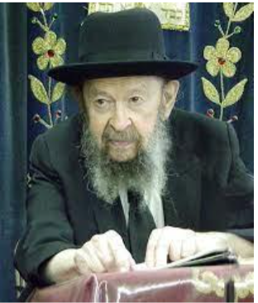

QUESTION: What general outlook can we use in order to make full use of the Three Weeks?
ANSWER: The Shulchan Aruch says רָאוּי לִהְיוֹת מֵצֵר וְדוֹאֵג עַל חֻרְבַּן בֵּית הַמִּקְדָּשׁ – it’s proper for people to be sad and worried about what we lost by the churban Beis Hamikdash (Orach Chaim 1:3).
Now, in general, if we keep in mind the fact that we once had a place where we could come together and demonstrate — now I’m saying something on the lowest possible level, but even that level is important — that ה’ הוּא הָאֱלֹקִים and He’s Elokei Yisroel, that He lives only by us, and we’re sad because we lost that tremendous opportunity, that’s already an achievement.
It’s so fundamental, this principle that הוּא ה’ אֱלֹקֵינוּ בְּכָל הָאָרֶץ מִשְׁפָּטָיו, that He’s Hashem Elokeinu and His judgments are over all the world (Tehillim 105:7). It means His judgments throughout the entire world are in the role of Hashem, Elokei Yisroel. Whatever happens in the world happens only because of us. All the changes in the history of nations that have taken place and will take place are because of us. And the Beis Hamikdash demonstrated that.
That’s what the Beis Hamikdash was — a demonstration that הַשְּׁכִינָה שׁוֹרָה בְּיִשְׂרָאֵל. Not that He’s Hashem, Elokei ha’olam, and we also worship Him. No, that’s not Torah. He is Hashem, Elokei Yisroel. Like it states at least 165 times in Tanach and many more times, other expressions. He belongs to us and we belong to Him! Of course, He is the Creator of the world, but we are His chosen people. And the Beis Hamikdash demonstrated that to the world.
And when that went lost, the kevod Shamayim, the glory of Hashem, the demonstration of His ruling the world as Elokei Yisroel went lost. And therefore, we should keep in mind as much as possible during the Three Weeks that this great demonstration has gone lost and that’s what they call golus haShechina, the Shechina is in exile. And we yearn to have that open demonstration once again.

Reprinted from a recent email of Torah Avigdor based on a question-and-answer session at the end of a July 1979 classic Thursday night hashkafah lecture of Rav Avigdor Miller, zt”l.

Thoughts that Count
for Our Parsha

You shall not add to that which I have commanded you nor shall you subtract from it, to observe the command of G-d (Deuteronomy 4:2).
The Torah is called the "prescription of life"-a medicine able to purify those who take it. That is why we are warned not to add and not to subtract from the Torah's words. A prescription drug is a precise mixture of various substances, and changing the proportions can have toxic effects. So, too, are the commandments of the Torah given in the exact and correct proportions, and to change even a word has a deleterious effect. (Rabbi Yonatan Eibeshutz)

The purpose of the "Enlightenment" was to reform the Torah and mitzvot. One of the proponents of that approach once suggested to Rabbi Azriel Hildesheimer that it was necessary to change certain detailed practices to make the observance of the commandments easier. Rabbi Hidesheimer replied "That is the meaning of the [above-mentioned] verse. Even when your purpose is to observe the command of G-d, you still may not subtract."

Reprinted from the Parshat Va’eschanan 5763/2003 (Issue #781) email of L’Chaim.

Are Dangerous Sports
Like Football and
Wrestling Kosher?
By Yehuda Shurpin

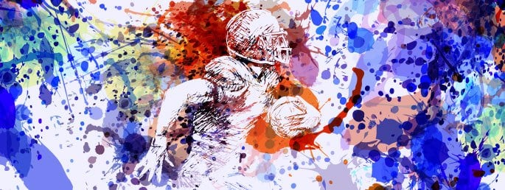

The Obligation to Avoid Risk
You may have read the title of this article and been surprised that this was even a question. After all, the prevailing sentiment today is “It’s my life and my body and I can do with it whatever I choose.” Judaism teaches us, however, that “a person's life is not his own property, it belongs to G-d.”¹ Each person was given the gift of life and put in this world for a specific purpose. Therefore, just as the prohibition of murder applies to others, it applies to oneself, and the same goes for injuring others or oneself.

In the words of the Code of Jewish Law:
A person should also be careful regarding anything that might cause danger, for we are stricter regarding danger than we are regarding Torah prohibitions . . . Therefore, it is forbidden to go to a dangerous place, such as alongside a dilapidated wall or to walk alone at night . . . and it is forbidden to rely on miracles or to endanger oneself in any such manner.²
So, is it permissible to participate in sports like football or wrestling, where there is a high risk of injury?

Dangerous Jobs
Regarding the obligation to pay wages in a timely manner, the Torah tells us, “You shall give him his wage on his day and not let the sun set over it, for he is poor, and he risks his life for it . . .”³ Focusing on the words “and he risks his life for it,” the Talmud explains that the verse is giving us a reason why you must pay on time, for this person risked his life doing his job; for example, “he suspended himself from a tree to gather olives or dates.”⁴
In a famous responsum, Rabbi Yechezkel Landau, known as the Noda B’Yehuda (1713 -1793), discusses the Jewish perspective on hunting:
I have thus far discussed the matter from the perspective of proper conduct. Now I wish to add that there might be an actual sin involved, too, since anyone who occupies himself with this [e.g., hunts] must enter forests, exposing himself to great danger from the many beasts lurking there. The Torah says, “And you shall guard yourselves very well” . . . So how can a Jewish person place himself where wild animals roam?
“Yet, even here, somebody who is poor and needs to hunt for his livelihood is permitted by the Torah to do so, just as merchants who travel the seas. Whatever a person needs to do for his livelihood must be permitted, as the Torah says, “. . . and he risked his life for it.” And our Sages say: Why did this man ascend a ladder, suspend himself from the tree, and risk death itself? Wasn’t it for his wages? But somebody whose intent is not for purposes of sustenance, but simply wants to satisfy the whims of his heart by going where wild animals lurk, and thus endangers himself, transgresses the verse: “And you shall guard yourselves very well.”
From the above it is clear that there are dangerous activities that may ordinarily be prohibited, but for financial considerations one may be permitted to do them. This brings us a step closer to our question about dangerous sports.

Contact Sports
Rabbi Moshe Feinstein writes that he was asked whether it is permissible to play professional ball despite the danger of getting hurt. Based on the Talmud we quoted earlier, he writes:
It is permitted to engage in a livelihood even if it involves a slight risk. Also, it should be permitted when there is a remote danger of killing others, for what is the difference between the prohibition against killing others and the prohibition against killing oneself? Killing oneself is also prohibited as murder, but it is permissible to take the risk for the sake of livelihood when the chances are minimal. Seeing as such is the case, it is also permitted when the minimal risk involved concerns injuring someone else. If this would not be so, how would it be permitted for the owner of a tree to hire a worker to climb it? Yet, this reasoning is only true if the other person takes the risk willingly. Otherwise, it would not be permitted to put others in even the slightest risk if they are unaware of it or if it is against their will.⁵

How Much Danger
It is thus clear that one can play professional sports to earn a livelihood even when there is a slight risk of bodily harm. But where do we draw the line?
In the responsum from Rabbi Moshe Feinstein, it is not clear which type of “ball” playing he is referring to. It can be argued that he was only talking about sports like baseball where there is only a minimal chance of injury. Indeed, there are some who explain that halachah permits activities where there is only a very slight risk of danger.⁶ This would seem to preclude participating in more dangerous activities like football or wrestling.
But there is another factor as well.
Rabbi Shlomo Zalman Auerbach writes that, in general, we look to the habits of the public to help determine whether something is deemed too dangerous. He determined that anything that the public “runs away from” out of fear of it being dangerous is, in fact, considered dangerous according to halachah, while anything that most people aren’t scared of is not.⁷
In other words, to determine whether it would be permissible, one would need to determine what the general public feels about it.
Since contact sports are generally not something people avoid, one could argue that neither should halachah view them as dangerous.

Selling Yourself to Cannibals (or Enlisting)
Rabbi Meir Eisenstaedter (known as the Maharam Ash, 1780–1852) notes that it is permitted for one to enlist in the army in times of peace. He further points to a fascinating incident in the Talmud that seems to have implications for our discussion.
Reish Lakish [who was known to be extremely poor] once sold himself to a group of cannibals (others translate the word as “gladiators”). He took a bag and a round stone inside of it with him. He said: “There is a tradition that on the final day of a captive’s life, before his captors kill him, they grant his any request, so that he would forgive them for his death.” On the final day before they were set to kill him, they said to him: “What would you like?”
He said to them: “I want to tie you up and have you sit and I will strike each one of you one and a half times.” He tied them up and had each one of them sit. When he struck each of them with one strike with the stone in the bag, they died, because Reish Lakish was of great strength. In order to prevent the others from realizing what was happening, Reish Lakish gritted his teeth in anger after each time he struck one of his captors: “Are you laughing at me? You still have half of a strike remaining with me, as I struck you only once.” He thus killed them all and escaped.⁸
Does this mean it is permitted to endanger oneself for monetary gain?
Reish Lakish was a very colorful personality, and before he devoted his life to Torah study, he was actually a bandit. Indeed, it is explained in Tosafot that this story must have taken place while Reish Lakish was still a bandit, before he returned to the proper path of Torah, “because afterward he would not have disgraced himself so much.”⁹
However, the Maharam Ash points out that Tosafot’s only issue with assuming that this story occurred later is the matter of proper decorum. There was no issue of it possibly being prohibited due to his putting himself in danger. This implies that his behavior was in fact permitted according to Jewish law.¹⁰
Accordingly, some explain that as long as an activity is not considered more dangerous than joining an army, it would be permitted.¹¹ Thus, both professional wrestling and football would be permitted.

Final Note
Note that not everything is clear-cut. On the one hand, we are still learning about the degree of danger involved. On the other hand, new regulations and better equipment make certain sports safer than they may have been in the past.
“A man's folly perverts his way, but his heart is wroth with the L-rd,” says King Solomon in Proverbs.¹² The Chassidic masters explain this to refer people who have what they need but are not satisfied. Wishing for riches, they seek out dangerous occupations and are “wroth with the L-rd” when, heaven forbid, they get injured.¹³
Thus, before you sign your big contract with the NFL or try out another dangerous sport, it is best to consult with a competent Orthodox rabbi to ascertain whether this is indeed right for you.
Footnotes
1. See commentary of Radbaz on Rambam, Hilchot Sanhedrin 18:6.
2. Rama, Shulchan Aruch, Yoreh De’ah 116:5. 3. Deuteronomy 24:15.
4. Talmud, Bava Metzia 112a and Rashi ad loc. 5. Igrot Moshe, Choshen Mishpat 1:104.
6. See, for example, responsum Achiezer 1:23.
7. Responsum Minchat Shelomo, Mahadura Tinyana 2-3:37; see also responsum Shem Aryeh, Yoreh De’ah 27. 8. Talmud, Gittin 47a. 9. Tosafot to Talmud, Gittin 47a. 10. Responsum Maharam Ash, Yoreh De’ah 52.
11. See Chashukei Chemed on Talmud, Bava Metziah 112a. 12. Proverbs 19:3.
13. See Maamar Mayim Rabim in Torat Shmuel 5636 vol. 1.
Reprinted from the current website of Chabad.Org
The Arab Family That
Has Protected a Synagogue for Over 100 Years
By Michal Arieli
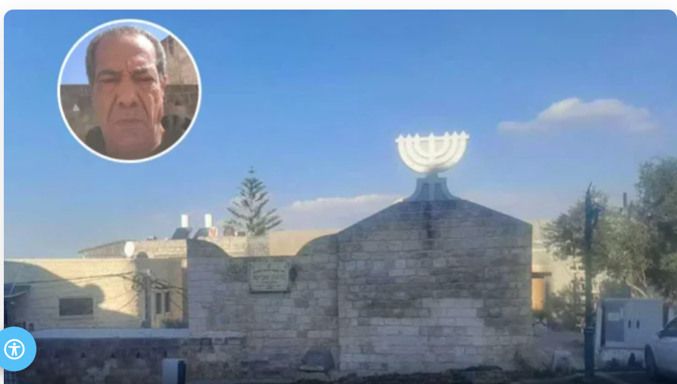
The synagogue in Shfaram (in the circle: Aadel Jaafari)

It is hard to find another synagogue in Israel located within an Arab city whose keys have been held by an Arab family for more than a century, whose caretaker is Arab by birth, and whose regular cleaning is handled by local Arab women.
Yet that is exactly the story of Machaneh Shechinah, the ancient synagogue of Shfaram. In this northern city, where Muslims, Christians, and Druze live side by side, residents have preserved a remarkable reminder of a Jewish community that once flourished there.
The Hebrew sign at the entrance still reads, "Beit Knesset Machaneh Shechinah." Before the last Jew left Shfaram in the early 1920s, he entrusted the synagogue's key to his Arab neighbors. More than one hundred years later, that same family is still guarding the building, maintaining it, and welcoming Jewish visitors who come to pray.
The Guardian of the Synagogue
Visitors arriving at the synagogue are often greeted by Aadel Jaafari, who proudly refers to himself as the synagogue's guardian.
In fluent Hebrew, he welcomes visitors and asks, "Would you like to go inside? Should I open it for you? You're welcome to pray."
Jaafari's connection to the synagogue stretches back generations.
"My grandfather bought the last house from a Jewish family that left Shfaram in 1922," he explains. "At first, he didn't realize the building had been a synagogue, so he brought his goats inside. Then the goats began dying one after another."
Concerned, his grandfather consulted a local sheikh, who suggested that perhaps he was disturbing something sacred. Remembering that the building had belonged to a Jewish family, he sought advice from a rabbi, who explained the significance of the structure.
"From that moment, my grandfather removed the goats, cleaned the building thoroughly, and treated it as a synagogue," Jaafari says.
Since then, the family has never used the building for any personal purpose. Instead, they have devoted themselves to maintaining and preserving it.
Aadel Jaafari, who holds the synagogue’s keys today.

Restoring a Piece of History
According to Jaafari, a major restoration project began in the 1950s under the direction of architect Meir Ben Uri, with assistance from Israel's Ministry of Religious Affairs. The work included renovations throughout the building as well as the redesign of the Holy Ark.
Years later, another major restoration effort was launched.
"I still remember when Ariel Sharon visited," Jaafari recalls. "My father explained that many people came to pray there, but no one was investing money in maintaining the building. If nothing was done, it would eventually collapse."
A unique agreement followed. The state would cover half the renovation costs, while Jaafari's father personally funded the other half.
"My father shook Sharon's hand, and from that point everything changed. Major renovations were carried out, and the synagogue became beautiful once again. Our family is very proud to have played a part in that."
A Key Passed From Generation to Generation
The synagogue remains active today, attracting visitors from across Israel.
Some come to pray, while others visit for bar mitzvah celebrations, family gatherings, or simply to experience a unique piece of Jewish history.
The building is not left open at all times, however.
"There are valuable items inside," Jaafari explains. "We don't want random people wandering in."
Instead, the key remains with the family. It was once held by his grandmother, then his father, and today it is in his hands.
"One day I will pass it on as well," he says. "The key will always remain with our family."

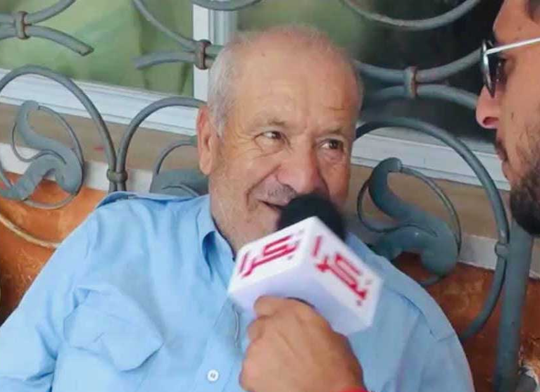
Aadel Jaafari’s father, who funded half the restoration.

The concern about security is not merely theoretical.
In 1985, thieves posing as scribes stole an ancient Torah scroll from the synagogue. According to Jaafari, the scroll was believed to be more than a thousand years old.
"My father and our entire family searched everywhere for it," he recalls. "Sadly, it was never recovered. I still remember opening it and seeing the parchment. It felt alive. It was truly special."
The Women Who Keep It Clean
Keeping the synagogue in good condition requires ongoing care.
That responsibility falls largely to Jaafari's aunt and three other local women, who take turns cleaning the building.
"Every week one of them comes, cleans the synagogue, and locks it afterward," he says.
Their work is entirely voluntary, part of the family's long-standing commitment to preserving the site.
"I Don't Take Any Payment"
Professionally, Jaafari works in construction, desalination, and power infrastructure. But caring for the synagogue is something entirely separate.
When asked whether he receives compensation for all the time and effort he invests, he seems genuinely surprised.
"Why should I be paid?" he asks. "I do it out of kindness and humanity."
He explains that when people once offered his father money for guarding the synagogue, his father refused.
"He would say, 'I do it for the mitzvah.' And that's exactly how I feel."
The family has spent decades opening and locking the building, cleaning it, maintaining it, and even contributing their own money toward renovations.
"We do it with love," Jaafari says. "We want there to be more kindness in the world."
More Than a Building
Over the years, Jaafari has welcomed countless visitors, including rabbis, Chassidim, and descendants of Jewish families who once lived in Shfaram.
His father often spoke fondly of the city's former Jewish residents and the friendships they shared.
"My father's best friends were Jewish children," he says. "They played together growing up."
Eventually, the family even organized gatherings with descendants of those former residents, helping reconnect people with their roots.
Although Jaafari does not describe himself as particularly religious, he speaks openly about his faith.
"I believe very much in G-d," he says. "I feel that He watches over us in a special way."
Then he pauses before offering a reflection that seems to capture the spirit of the synagogue itself.
"I think that no matter who we are, Jews, Muslims, or Druze, in the end we all pray to the same One. If people lose their humanity and their desire to help others, it becomes very easy to lose our way."
For more than a century, one family in Shfaram has quietly lived by those words, protecting a synagogue that is not their own and preserving a remarkable chapter of Jewish history for future generations.

Reprinted from the current website of Hidabroot.com

